Fall 2024
HCI Final Project Description

Project Objectives

This project aims in understanding the following:
- Understanding users and their requirements

- Identifying innovative mechanisms and procedures that how users work can be improved

- Developing prototypes for user practices

- Identifying new metaphors and artifacts to improve design

- Improving Usability

- Application of Usability

This project demands developing scenarios and personas to understand user requirement and an innovative use of computation and technology to improve the work efficiency.

Instruction

In this Project, you will be Applying, Analyzing and Evaluating any one application interface and designing your own interfaces for different category of users. The list of applications which you will be targeting for the project is listed below:

- UPaisa
- HBL Konnect
- PayPro
- SadaPay
- NayaPay
- Bookme.pk
- FonePay
- Zindigi by JS Bank
- JazzCash
- EasyPaisa
- Keenu Wallet

Your first task is to identify the problem, analyze and evaluate any one application mention above based upon the factors, theories, rules, and concepts which we learned throughout the course. Your main goal is to come up with an innovative non-cash payment method that is acceptable to every type of user for day-to-day transactions.

Secondly you have thought that how to overcome those issues which you identify above and start thinking about redesigning the application according to users.

Your second task is to redesign the interfaces according to different users keeping in mind all the concept we have learn throughout the course and provide you reasons along with each interface design that why you choose that pattern for this particular user.

Your third task is to use different evaluation methods and evaluate your own design with the specific targeted groups. Evaluation method is mention below:

- Heuristics Evaluation

- Cognitive Walkthrough

- Think a loud Protocol

- Usability testing Questionnaire
Project Detail Overview
The project’s overall goal is to understand users’ need in significant depth that your team can develop new interfaces, processes, and artifacts. This aspect suggests creativity from your team’s side, and an improved system with real value to the intended users.

The project is divided up into two primary phases:

1. Frist Phase
Field studies. In the first phase, you should observe, analyze and evaluate the interface. For this you might need to interview users. This information will help you to understand the users' goals, needs, capabilities, culture of practice, and any constraints within which they must operate as they perform their task. At the same time, you will characterize how well their current interface meet their needs, looking for ways to improve the interface. These data will result in a set of models that describe work practices and deficiencies in their current interface.

Deliverables for Phase 1:
Report on your survey, identifying:
- What is your sample? How many users you have studied? What was the context of the study?

- Identifying what problems users are facing. How you identified these problems, and how and what sort of data you collected?
- How current interface are utilized and how they can be improved?

- What models you are proposing for designing the new solution for different type of users?

2. Second Phase
The Second Phase is divided onto two section Design phase and Evaluation Phase.
- Design. In the second phase, you will take the results from the first phase and redesign the interface according to different users’ group which include Senior citizen, Disabled people and illiterate people. Importantly, you will be creating running prototypes in this phase and provide a reason that why you choose that pattern for this user groups.

Deliverables for Phase 2a:
Running Prototypes for each type of user groups and Report on your design, based on:
- How have you come to your novel idea?
- Provide you reasons along with each interface design that why you choose that pattern for this user. How is your idea addressing the problems identified in Frist phase?

- Evaluation. Since in this you are creating high-fidelity representations of a final system design, which may not need to be fully functional, but must be nearly identical to a final form so that they may be realistically evaluated. You will employ HCI evaluation techniques to demonstrate the ways your design improves upon existing methods.

Deliverables for Phase 2b:

Report on your survey, including:

- What type of Evaluation methods you have used?

- Description regarding material you used for evaluation i.e. questionnaire, scenarios or observation statements.

Project Deadlines

Project Hand out: September 9th , 2024

Deadline for Phase 1: October 17th, 2024

Deadline for Phase 2: November 16th, 2024

Presentations and Running Demo: November 20th, 2024
Samples of Four Techniques

For choosing user for every technique make sure to target two different groups of users. Mention your targeted user with every technique.

- A sample of few expert questionnaires as shown below (Don’t used the same question take it as reference).
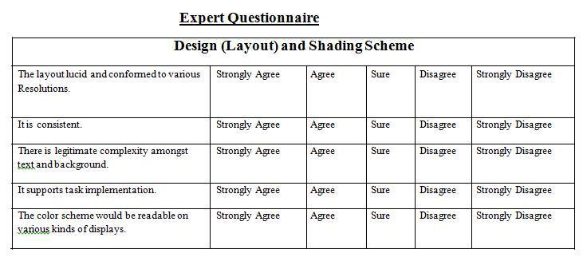

- A sample of few scenario as shown below (Don’t used the same scenario take it as reference).

  - Buy this particular product through credit card.

  - Make your GD through ERP.

- A sample of few factor which covered in usability testing as shown below

Take at least 15 factors and based upon it make a questionnaire or scenario or anything you like.

Some of the factors are as follow:

- Simplicity

- Affordance

- Mapping

- Efficiency

- Effectiveness

- Flexibility

- Reducing Cognitive burden

- Satisfaction

  - Feedback

  - Visibility

  - Learnability

  - Memorability

- What is Think aloud?

Think aloud protocols consist of observing a user working with an interface while encouraging them to "think-aloud"; to say what they are thinking and wondering at each moment. Think-aloud protocols are of particular value because they focus on the problems a user has; when the user is working without difficulty, direct observation (and hence the think-aloud protocol itself) is of very limited use. This is because the user is unable to communicate as fast as they think and act, unless a specific problem arises which slows them down. It is at these times when this method really shines as it allows the observer to correlate the actions and statements of the participant.

We see the main advantages of this method as:

  - Rapid, high-quality, qualitative user feedback (e.g. as compared with questionnaires).


  - Data is available from a broad range of sources, such as Direct observation of what the subject is doing and Hearing what the subject wants, or is trying, to do.

  - If the subject gets into difficulties, the observer has the chance to clarify the situation.
  - High degree of flexibility; the experiment may easily be steered by the observer.
  - The presence of two people allows meaningful, direct dialogue.

Furthermore, the protocol may be used in two distinct scenarios.

- The observer specifies a definite task to be accomplished by the subject. This allows the observer to concentrate on a specific task they are interested in.

- 'Open-ended'; no task is specified, and the user is free to choose their own task. Allows the observer to concentrate on naturally occurring problems

